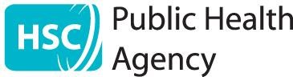
Health Protection Duty Room
Public Health Agency
12-22 Linenhall Street
Belfast
BT2 8BS

Website:- www.publichealth.hscni.net
9th October 2020
St Peter’s Primary School
4 Ross Road
Belfast
BT12 4JD

Dear Parent / Guardian,

RE: Confirmed COVID case in St Peter’s Primary School

The Public Health Agency has been notified of a confirmed case of COVID-19 in the St
Peter’s Primary School community. The Public Health Agency has worked with the school principal to undertake a risk assessment to identify people who have been in close contact with the case. These individuals have been advised to stay at home and isolate.

In completing this risk assessment your child has not been identified as a close contact in the school setting and does not need to make any change to their usual routine, including school attendance.

The most common symptoms of COVID-19 are recent onset of:
- new continuous cough and/or
- high temperature and/or
- a loss of, or change in, normal sense of taste or smell (anosmia)

If your child, or anyone in your household, develops any of these symptoms, your whole household must remain at home and not go to work, school or public areas. You should arrange testing for the person who has developed symptoms. Testing for all symptomatic individuals in Northern Ireland can be booked at www.nhs.uk/ask-for-a-coronavirus-test . When the result is known further advice will be available.

How to stop COVID-19 spreading

There are things you can do to help reduce the risk of you and anyone you live with getting ill with COVID-19:

- Wash your hands with soap and water often – do this for at least 20 seconds
- Use hand sanitiser gel if soap and water are not available
- Wash your hands as soon as you get home
- Cover your mouth and nose with a tissue or your sleeve (not your hands) when you cough or sneeze
- Put used tissues in the bin immediately and wash your hands afterwards

Further information
For further information, please see the Public Health Agency website https://www.publichealth.hscni.net/covid-19-coronavirus or contact NHS 111. If your child feels unwell and you are worried about their symptoms or about anyone else in the home, please contact your GP.

Yours sincerely,

Dr Joanne McClean
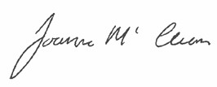
Consultant in Public Health Medicine

